|  |
| --- |
| EPAM Systems, RD Dep. |
| MTN.BI.08 Transportation |

|  |  |  |  |  |  |
| --- | --- | --- | --- | --- | --- |
| REVISION HISTORY | | | | | |
| Ver. | Description of Change | Author | Date | Approved | |
| Name | Effective Date |
| 1.0 | Initial status | [Kiryl Bucha](mailto:Kiryl_Bucha@epam.com) | 12-JAN-2012 |  |  |
| 2.0 | Updated in accordance with renewed content | [Elias Nema](mailto:Elias_Nema@epam.com) | 20-JAN-2014 |  |  |
| 3.0 | Report | Aksana Kuratnik | 07-DEC-2017 |  |  |

Contents

1. ETL Transportation - Analytical 3

1.1. Transportation Description 3

2. ETL Extraction – Example of Loading FCT_* 3

2.1. Prepare Table of Facts to SAL Layer 3

3. Transportable Tablespaces and DBLinks 3

4. Hierarchies 3

# Transportable Tablespaces and DB Links

Create sample usage of transportable tablespaces and database links and describe it in document with screenshots and description.

**DB LINK:**

Creation of a new tablespace:

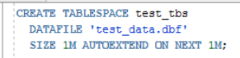

Creation of a new user:



Grants to test_user were addes:

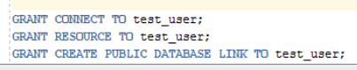

Creation of the DB LINK:

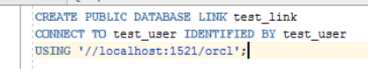

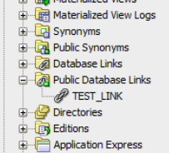

Test DB LINK:

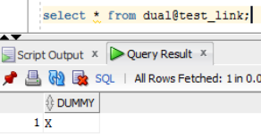

# Table Functions

Creation of the type to support table functions:

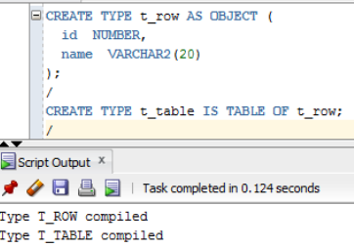

Creation of table function:

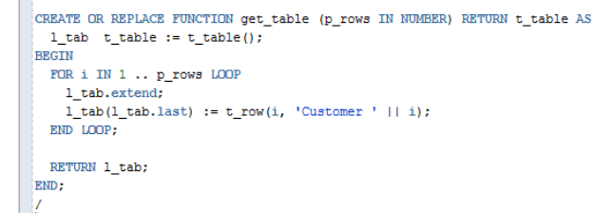

Test table function:

